**6CLP Assignment – Report Template**

|  |  |
| --- | --- |
| Student ID | Name |
| 000712169 | Matthew Palmer |

**Gather and Document Requirements**

|  |  |
| --- | --- |
| **Considerations** | **Response** |
| **1.1** Cloud solution vs private ISP hosting – Which Option and Why | Cloud is more accommodating to scalability and is much easier to manage than private hosting. |
| **1.2** If it is a cloud service, which one – AWS, Google App Engine or Azure? (justify your choice) | Azure is my choice because it supports Microsoft based applications which includes C#. Google App Engine does not appear to support C# - AWS may do but is not a Microsoft based service and may present compatibility difficulties. |
| **1.3** Implementation of Core Services- choices are ASP.NET Web Service, MVC, WCF service or REST? (Justify your choice) | WCF seems to be the best choice for implementation – the others are outdated. |
| **1.5** Database deployment options- current legacy system or deployed as a cloud-based database (Think scalability and Compatibility) | Deployment as a cloud base application was determined to be the best choice. Such a database is easy to host and access, and can continue to grow beyond the size of a local SQL database. It also allows for sharing of database information with little effort. |

**Use Case Model**

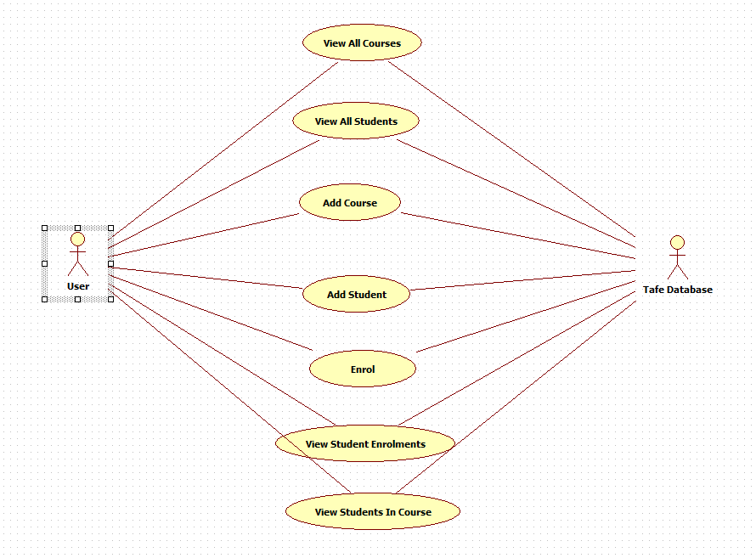

**Use Case Priority List**

|  |  |  |
| --- | --- | --- |
| **Use Case** | **Priority** | **Justification** |
| Add Course | 1 | Course needs to be added before it can be viewed |
| View Course | 2 | Once course added, View Course will give results |
| Add Student | 3 | Student needs to be added before it can be viewed |
| View Student | 4 | Once student added, View Student will give results |
| Enrol | 5 | Once Course and Student added, an enrolment can be made |
| View Student Enrolments | 6 | Can be used when there is an enrolment |
| View Students In Course | 7 | Can be used when there is an enrolment |

**Glossary (Define Application Terms here)**

|  |  |
| --- | --- |
| **Term/Phrase** | **Definition** |
| Student | A person enrolled at TAFE which can enrol in a Course |
| Course | A unit representing a course taugh at TAFE in which a Student can enrol |
| Enrolment | Representation of a Student enrolment into a Course |
| TafeDB | The TAFE enrolment database on Microsoft Azure |
| ABC Ed Services | A client for the ABCEdWCFServices cloud based software which allows the addition of Student, Course and Enrolment along with view of database contents. |
| ABCEdWCFService | Cloud based services for the manipulation of the TafeDB database |

**Implementation Mechanisms**

|  |  |
| --- | --- |
| **Mechanism** | **Description** |
| **Persistence** | **Using the Entity Manager with SQL Server Database** |
| **Message Formatting** | **XML** |
| **Serialization** | **DataContract serializer** |
| **Endpoints** | **Basic Http** |

**Development environment and tools required**

***Microsoft Visual Studio 2015***

***Azure SDK***

***Microsoft SQL Server***

**UML Model - Design Classes and relationship**

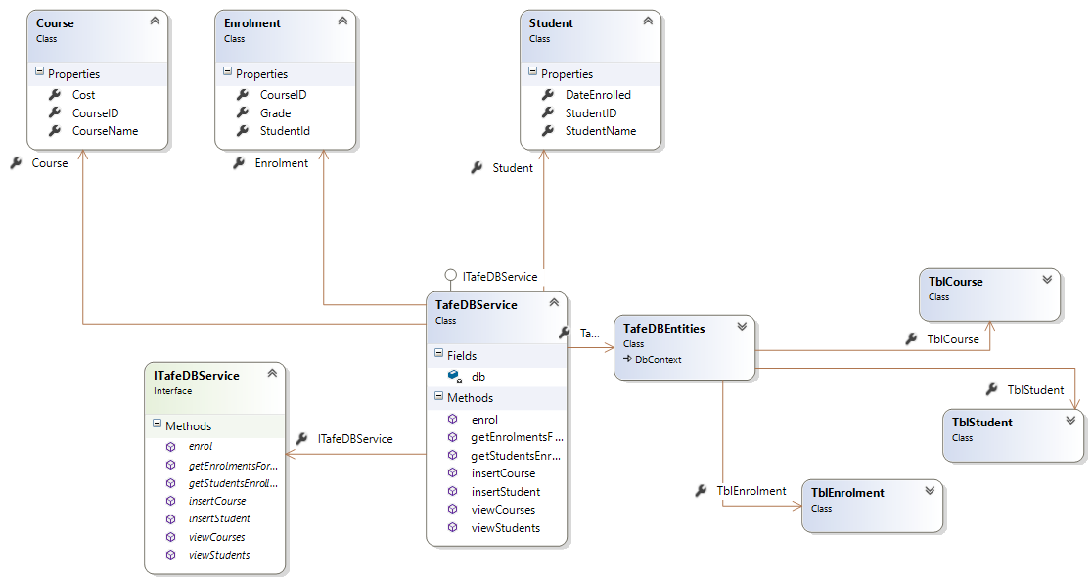

**A UML component model**



**Test Plan**

**Testing Service Before Publishing**

|  |  |  |  |  |
| --- | --- | --- | --- | --- |
| **Service** | **Input** | **Expected Output** | **Actual Output** | **Comments** |
| **insertStudent** | **ID = abc, Name = Joey, DateEnrolled 31 may** | **1** | **1** |  |
| **viewStudents** | **None** | **List containing student Joey** | **List containing student Joey** |  |
| **insertCourse** | **ID = boo, Name = boo course, cost = 100** | **1** | **1** |  |
| **viewCourses** | **None** | **List containing boo course** | **List containing boo course** |  |
| **Enroll** | **courseID = boo, studentID = abc** | **1** | **1** |  |
| **getStudentEnrolled**  **InCourse** | **courseID = boo** | **Student Joey** | **Student Joey** |  |

**Testing Service After Publishing**

|  |  |  |  |  |
| --- | --- | --- | --- | --- |
| **Service** | **Input** | **Expected Output** | **Actual Output** | **Comments** |
| **Add a new student** | **ID = qqq, name = qwerty, date = now** | **New Student Information Saved** | **New Student Information Saved** |  |
| **View course** | **None** | **List of students including qqq** | **List of students including qqq** |  |
| **Add New Course** | **ID = www, name = azerty, cost = 10** | **New Course Information Saved** | **New Course Information Saved** |  |
| **View courses** | **None** | **List of courses containing www** | **List of courses containing www** |  |
| **Enroll Student** | **Course = www, Student = qqq** | **New Enrollment Information Saved** | **New Enrollment Information Saved** |  |
| **Display Bill** | **Student = qqq** | **Qwerty, $10.00, azerty** | **Qwerty, $10.00, azerty** |  |
| **View Enrolments** | **Course = www** | **Qwerty (azerty, $10.00)** | **Qwerty (azerty, $10.00)** |  |

**Further NUnit tests on ABCEdWCFService**

Testing class getters and setters

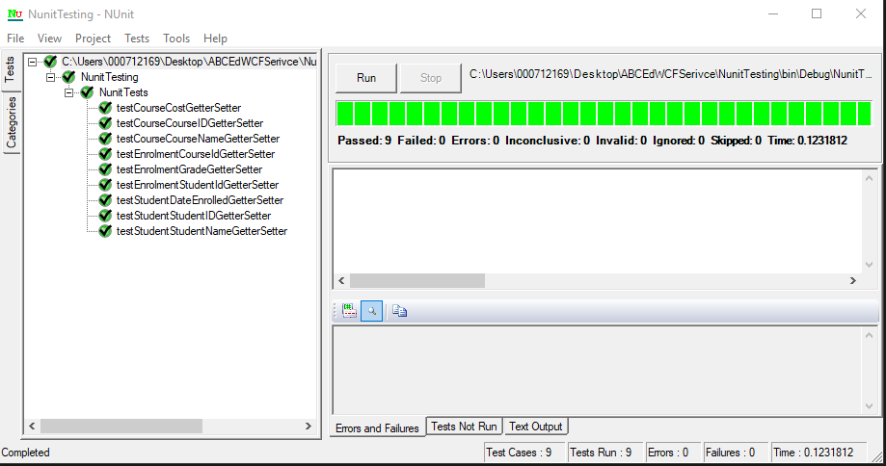

**Steps - Deploying /Publishing your services**

1. **Go to manage.windowsazure.com**
2. **Click on SQL database**
3. **Create new database with creation scripts generated from original SQL file**
4. **In new WCF application, link to new hosted SQL database**
5. **Make sure when using VisualStudio, user is logged to utilize WindowsAzure service**
6. **When WCF functions have been tested and determined to be function, the WCF project is then published onto WindowsAzure**
7. **A url is given – this is modified to link to the new cloud services. It can be given to a client in order to establish communications with these services.**

**Further Research**

**-Big Data Considerations (500 words)**

## A brief description of Big Data

Big data is the derivation of valuable information from large amounts of data through non-traditional means. If the data is too large and complicated for such methods to deal with, other methods for information derivation are used. This is necessary as the volume of data produced by the world is growing exponentially.

Big data is categorised into three categories – volume, velocity and variety. A fourth, Veracity is also sometimes used.

**Volume** refers to the amount of data available. Typical relational databases are not able to cope well with increasingly voluminous data sources.

**Velocity** is the rate of data entering computing systems which may be too great for such computers to deal with.

**Variety** refers to the expanding amount of different data types, and information contained within. Traditional computing techniques have difficulty categorising and storing such data.

In addition to the three categories listed above, **Veracity** is also sometimes used. This refers to the quality of data captured and how well it can be used for data analytics.

Organizations by necessity tend to ignore most of the data it is presented with. As a result, much valuable information is being discarded. Big data analytics attempts to solve this problem.

## Big Data Technologies

### Hadoop

Hadoop is an open source software library for distributed computing. It can be used as a platform for big data analysis spread over multiple server computers. Hadoop is also designed to compensate for individual computer failures thus allowing reliable data analytics via cheaper and lest specialized computer systems.

### Cloud Based Big Data

There are a number of cloud based Big Data solutions available for organizations which cannot afford the necessary computing hardware. One such service is Data Lake Analytics, offered by Microsoft Azure.

In addition to this, there are many publicly available data sets.

## Big Data and ABCEd Services

The data set currently gleaned by this application is limited and can be analysed successfully by traditional computational means. However, with the expansion of the online TAFE database (which is easier when done in the cloud), traditional data analytics may be insufficient. Combined with other data sources, TAFE may require big data analytics to derive greater useful information from these sources. It would be worth investigating cloud based big data services to achieve this aim.

Microsoft Azure offers Data Lake Analytics which may be useful for this purpose. It can be used for large scale parallel data processing programs in a variety of languages. This service is available for a fee, the fee determined by the amount of work performed.

**-Xml Serialization vs. JSON Serialization**

XML Advantages

* Metadata can be placed in the tags as attributes
* Typically rendered by browsers and other applications in an easy to read format

JSON advantages

* JSON files are smaller than XML files, and therefore use less bandwidth
* JSON tends to use less CPU cycles when being decoded/encoded

An XML file may look like this

<person>

<name>Matt Palmer</name>

<phone>12345678</phone>

</person>

The same in JSON would look like this

Person {

“name”: Matthew Palmer,

“phone”: 12345678

}

**-ASP.NET MVC vs. WCF Services**

Using WCF services offers the advantage over ASP.NET of offering a cloud service which can be scaled up as required. Also, the as the services are in the cloud, their functions can be effectively distributed over many computers.

**-Windows Forms vs. ASP.NET Html Views**

Using ASP.NET is preferable to Windows Forms as a dedicated computer needs to be set up in order to run the Windows Forms application. On the other hand, an ASP.NET front end can be accessed from any internet ready computer with a browser. Coupled with a WCF service, ASP.NET is an excellent choice compared to Windows Forms.